Please fill out this application, paste 1-2 pages of a picture book writing sample below, and send back as a single Word doc attachment to this email address: rosiejpova.author@gmail.com
* * *
1. How long have you been writing for?
2. What age groups and genres? (picture books, chapter books, middle grade, YA, adult etc. / fiction, non-fiction)
3. What are your biggest struggles and challenges with the craft and/or the publishing business?
4. What are your writing and publishing goals?
5. What kind of support would you like to get from a mentorship?
6. Ideally, when would you like to start with your mentorship?
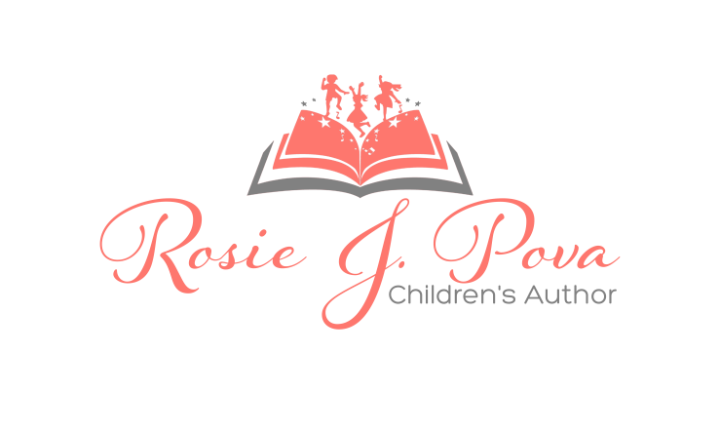
7. Anything else you'd like to share?

Learn more about the mentorship at: rosiejpova.com/writing-workshops
www.rosiejpova.com

